1150080065_Nguyễn Quang Mẫn
Lab1
Tạo Trang chủ để liên kết 3 bài
AndroidManifest.xml
<?xml version="1.0" encoding="utf-8"?>
<manifest xmlns:android="http://schemas.android.com/apk/res/android"
xmlns:tools="http://schemas.android.com/tools">
<uses-permission android:name="android.permission.CALL_PHONE" />
<uses-permission android:name="android.permission.SEND_SMS" />
<application
android:allowBackup="true"
android:dataExtractionRules="@xml/data_extraction_rules"
android:fullBackupContent="@xml/backup_rules"
android:icon="@mipmap/ic_launcher"
android:label="@string/app_name"
android:roundIcon="@mipmap/ic_launcher_round"
android:supportsRtl="true"
android:theme="@style/Theme.Lab1">
<activity
android:name=".MainActivity"
android:exported="false" />
<activity
android:name=".Xucxac"
android:exported="false" />
<activity
android:name=".Goidien"
android:exported="false" />
<activity
android:name=".Trangchu"
android:exported="true">
<intent-filter>
<action android:name="android.intent.action.MAIN" />
<category android:name="android.intent.category.LAUNCHER" />
</intent-filter>
</activity>
</application>
</manifest>
Trangchu.java
package com.example.lab1;
import androidx.appcompat.app.AppCompatActivity;
import android.content.Intent;
import android.os.Bundle;
import android.view.View;
import android.widget.Button;
public class Trangchu extends AppCompatActivity {
@Override
protected void onCreate(Bundle savedInstanceState) {
super.onCreate(savedInstanceState);
setContentView(R.layout.trangchu);
Button btnBai1 = findViewById(R.id.btnBai1Calculator);
Button btnBai2 = findViewById(R.id.btnBai2DiceRoller);
Button btnBai3 = findViewById(R.id.btnBai3CallSms);
// Chuyển sang Bài 1: Máy tính
btnBai1.setOnClickListener(new View.OnClickListener() {
@Override
public void onClick(View v) {
Intent intent = new Intent(Trangchu.this, MainActivity.class);
startActivity(intent);
}
});
// Chuyển sang Bài 2: Tung Xúc Xắc
btnBai2.setOnClickListener(new View.OnClickListener() {
@Override
public void onClick(View v) {
Intent intent = new Intent(Trangchu.this, Xucxac.class);
startActivity(intent);
}
});
btnBai3.setOnClickListener(new View.OnClickListener() {
@Override
public void onClick(View v) {
Intent intent = new Intent(Trangchu.this, Goidien.class);
startActivity(intent);
}
});
}
}
TrangChu.xml
<?xml version="1.0" encoding="utf-8"?>
<LinearLayout
xmlns:android="http://schemas.android.com/apk/res/android"
xmlns:tools="http://schemas.android.com/tools"
android:layout_width="match_parent"
android:layout_height="match_parent"
android:orientation="vertical"
android:gravity="center"
android:padding="32dp"
tools:context=".Trangchu">
<TextView
android:layout_width="wrap_content"
android:layout_height="wrap_content"
android:text="Chọn Bài Tập"
android:textSize="30sp"
android:textStyle="bold"
android:layout_marginBottom="50dp"/>
<Button
android:id="@+id/btnBai1Calculator"
android:layout_width="match_parent"
android:layout_height="wrap_content"
android:text="Bài 1: Máy Tính Đơn Giản"
android:textSize="20sp"
android:padding="16dp"
android:layout_marginBottom="20dp"/>
<Button
android:id="@+id/btnBai2DiceRoller"
android:layout_width="match_parent"
android:layout_height="wrap_content"
android:text="Bài 2: Tung Xúc Xắc"
android:textSize="20sp"
android:padding="16dp"/>
<Button
android:id="@+id/btnBai3CallSms"
android:layout_width="match_parent"
android:layout_height="wrap_content"
android:text="Bài 3: Gọi và Nhắn Tin"
android:textSize="18sp"
android:padding="16dp"/>
<TextView
android:layout_width="wrap_content"
android:layout_height="wrap_content"
android:text="Nguyễn Quang Mẫn"
android:textSize="30sp"
android:textStyle="bold"
android:layout_marginBottom="50dp"/>
</LinearLayout>
Kết Quả
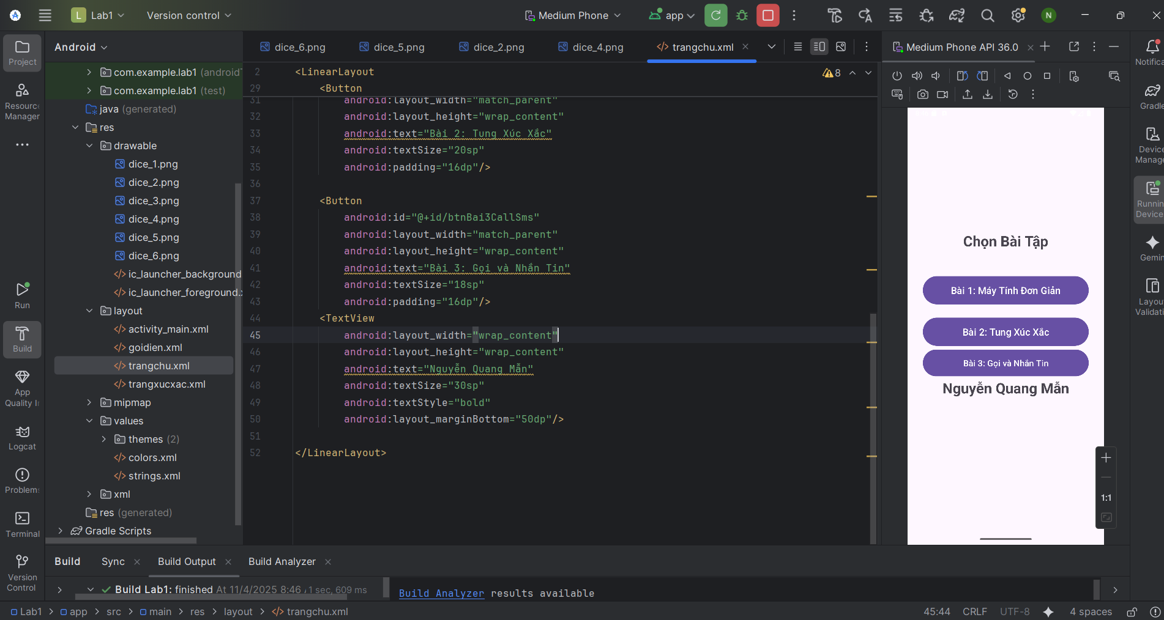
Bài 1
Activity_main.xml
<?xml version="1.0" encoding="utf-8"?>
<LinearLayout
xmlns:android="http://schemas.android.com/apk/res/android"
xmlns:tools="http://schemas.android.com/tools"
android:layout_width="match_parent"
android:layout_height="match_parent"
android:orientation="vertical"
android:weightSum="10"
tools:context=".MainActivity">
<EditText
android:id="@+id/txtX"
android:layout_width="match_parent"
android:layout_height="0dp"
android:layout_weight="1"
android:gravity="center"
android:hint="@id/txtX"
android:inputType="numberDecimal" />
<EditText
android:id="@+id/txtY"
android:layout_width="match_parent"
android:layout_height="0dp"
android:layout_weight="1"
android:gravity="center"
android:hint="@id/txtY"
android:inputType="numberDecimal" />
<TextView
android:id="@+id/txtResult"
android:layout_width="match_parent"
android:layout_height="0dp"
android:layout_weight="1"
android:gravity="center"
android:text="@string/result"
android:textSize="24sp"
android:textStyle="bold" />
<LinearLayout
android:layout_width="match_parent"
android:layout_height="0dp"
android:layout_weight="1"
android:orientation="horizontal"
android:weightSum="5">
<Button
android:id="@+id/btnPlus"
android:layout_width="0dp"
android:layout_height="match_parent"
android:layout_weight="1"
android:text="@string/plus" />
<Button
android:id="@+id/btnMinus"
android:layout_width="0dp"
android:layout_height="match_parent"
android:layout_weight="1"
android:text="@string/minus" />
<Button
android:id="@+id/btnMultiply"
android:layout_width="0dp"
android:layout_height="match_parent"
android:layout_weight="1"
android:text="@string/multiply" />
<Button
android:id="@+id/btnDivide"
android:layout_width="0dp"
android:layout_height="match_parent"
android:layout_weight="1"
android:text="@string/divide" />
<Button
android:id="@+id/btnModulus"
android:layout_width="0dp"
android:layout_height="match_parent"
android:layout_weight="1"
android:text="@string/modulus" />
</LinearLayout>
<TextView
android:text="Nguyễn Quang Mẫn"
android:layout_width="match_parent"
android:layout_height="0dp"
android:layout_weight="1"
android:gravity="center"
android:textSize="24sp"
android:textStyle="bold" />
</LinearLayout>
MainActivity.java
package com.example.lab1;
import android.graphics.Color;
import android.os.Bundle;
import android.view.View;
import android.widget.Button;
import android.widget.EditText;
import android.widget.TextView;
import androidx.activity.EdgeToEdge;
import androidx.appcompat.app.AppCompatActivity;
import androidx.core.graphics.Insets;
import androidx.core.view.ViewCompat;
import androidx.core.view.WindowInsetsCompat;
public class MainActivity extends AppCompatActivity {
private EditText txtX, txtY;
private TextView txtResult;
private Button btnPlus, btnMinus, btnMul, btnDiv, btnMod;
@Override
protected void onCreate(Bundle savedInstanceState) {
super.onCreate(savedInstanceState);
EdgeToEdge.enable(this);
setContentView(R.layout.activity_main);
// Làm cho giao diện tràn viền và nằm sát dưới camera
getWindow().setStatusBarColor(Color.TRANSPARENT);
ViewCompat.setOnApplyWindowInsetsListener(findViewById(android.R.id.content), (v, insets) -> {
Insets systemBars = insets.getInsets(WindowInsetsCompat.Type.systemBars());
v.setPadding(0, 0, 0, 0); // loại bỏ padding mặc định
return insets;
});
initControl();
}
private void initControl() {
txtX = findViewById(R.id.txtX);
txtY = findViewById(R.id.txtY);
txtResult = findViewById(R.id.txtResult);
btnPlus = findViewById(R.id.btnPlus);
btnMinus = findViewById(R.id.btnMinus);
btnMul = findViewById(R.id.btnMultiply);
btnDiv = findViewById(R.id.btnDivide);
btnMod = findViewById(R.id.btnModulus);
// Tạo 1 listener chung cho 5 nút
View.OnClickListener listener = new View.OnClickListener() {
@Override
public void onClick(View view) {
try {
double x = Double.parseDouble(txtX.getText().toString());
double y = Double.parseDouble(txtY.getText().toString());
double result = 0;
int id = view.getId();
if (id == R.id.btnPlus) {
result = x + y;
} else if (id == R.id.btnMinus) {
result = x - y;
} else if (id == R.id.btnMultiply) {
result = x * y;
} else if (id == R.id.btnDivide) {
if (y == 0) {
txtResult.setText("Lỗi chia 0");
return;
}
result = x / y;
} else if (id == R.id.btnModulus) {
if (y == 0) {
txtResult.setText("Lỗi chia 0");
return;
}
result = x % y;
}
txtResult.setText(String.valueOf(result));
} catch (NumberFormatException e) {
txtResult.setText("Lỗi nhập số");
}
}
};
// Gắn sự kiện cho nút
btnPlus.setOnClickListener(listener);
btnMinus.setOnClickListener(listener);
btnMul.setOnClickListener(listener);
btnDiv.setOnClickListener(listener);
btnMod.setOnClickListener(listener);
}
}
String.xml
<resources>
<string name="app_name">Lab1</string>
<string name="result">Kết quả </string>
<string name="plus">+</string>
<string name="minus">-</string>
<string name="multiply">*</string>
<string name="divide">/</string>
<string name="modulus">%</string>
</resources>

Kết quả
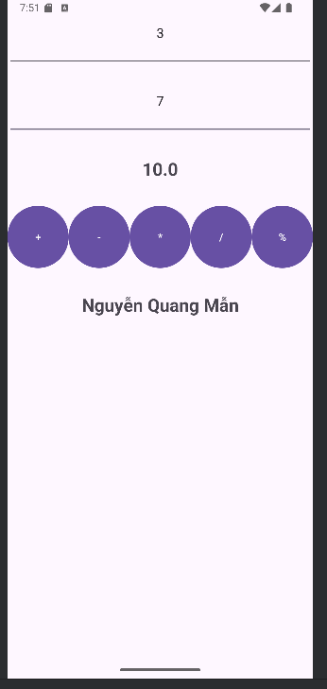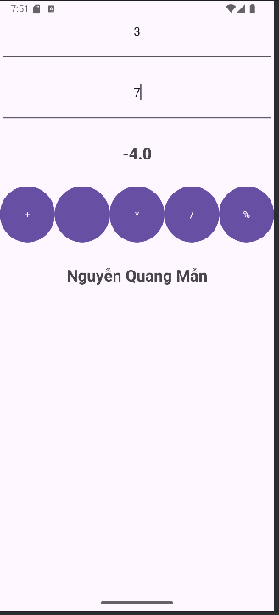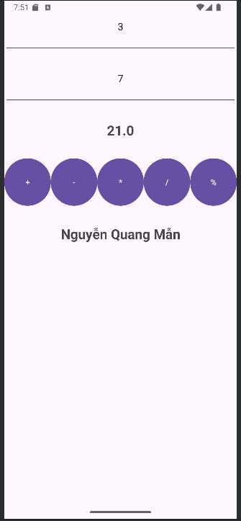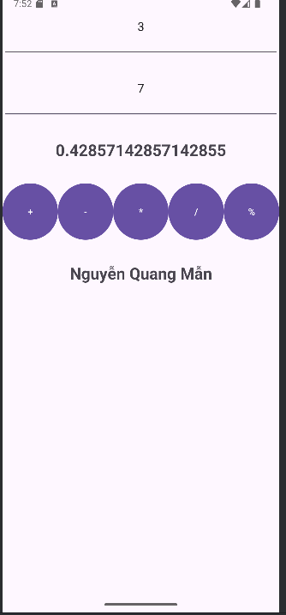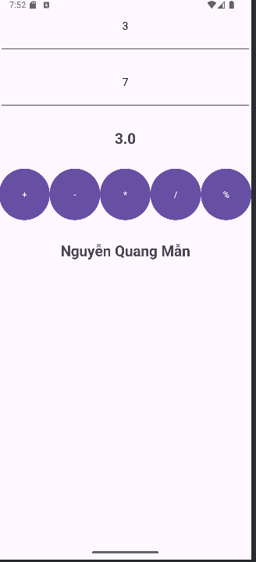

Bài 2
XucXac.java
package com.example.lab1;
import android.os.Bundle;
import android.view.View;
import android.widget.Button;
import android.widget.ImageView;
import android.widget.TextView;
import androidx.appcompat.app.AppCompatActivity;
import java.util.Random;
public class Xucxac extends AppCompatActivity {
private TextView txtDiceNumber;
private ImageView imgDice;
private Button btnRoll;
private final Random randomGenerator = new Random();
// Mảng chứa ID hình ảnh cho 6 mặt xúc xắc
private final int[] diceImages = {
R.drawable.dice_1,
R.drawable.dice_2,
R.drawable.dice_3,
R.drawable.dice_4,
R.drawable.dice_5,
R.drawable.dice_6
};
@Override
protected void onCreate(Bundle savedInstanceState) {
super.onCreate(savedInstanceState);
setContentView(R.layout.trangxucxac);
// Ánh xạ các control
txtDiceNumber = findViewById(R.id.txtDiceNumber);
imgDice = findViewById(R.id.imgDice);
btnRoll = findViewById(R.id.btnRoll);
// Thiết lập sự kiện cho nút "Tung Xúc Xắc"
btnRoll.setOnClickListener(new View.OnClickListener() {
@Override
public void onClick(View v) {
rollDice();
}
});
}
private void rollDice() {
// 1. Tạo số ngẫu nhiên từ 1 đến 6
int diceResult = randomGenerator.nextInt(6) + 1;
// 2. Cập nhật TextView hiển thị số xúc xắc
txtDiceNumber.setText(String.valueOf(diceResult));
// 3. Cập nhật hình xúc xắc tương ứng
int imageResourceId = diceImages[diceResult - 1];
imgDice.setImageResource(imageResourceId);
}
}
Trangxucxac.xml
<?xml version="1.0" encoding="utf-8"?>
<androidx.constraintlayout.widget.ConstraintLayout xmlns:android="http://schemas.android.com/apk/res/android"
xmlns:app="http://schemas.android.com/apk/res-auto"
android:layout_width="match_parent"
android:layout_height="match_parent"
android:padding="24dp">
<!-- Hiển thị số mặt xúc xắc -->
<TextView
android:id="@+id/txtDiceNumber"
android:layout_width="wrap_content"
android:layout_height="wrap_content"
android:text="0"
android:textColor="#F44336"
android:textSize="48sp"
app:layout_constraintTop_toTopOf="parent"
app:layout_constraintStart_toStartOf="parent"
app:layout_constraintEnd_toEndOf="parent"
app:layout_constraintBottom_toTopOf="@id/imgDice"
app:layout_constraintVertical_bias="0.2" />
<!-- Hình xúc xắc -->
<ImageView
android:id="@+id/imgDice"
android:layout_width="200dp"
android:layout_height="200dp"
android:src="@drawable/dice_1"
app:layout_constraintTop_toBottomOf="@id/txtDiceNumber"
app:layout_constraintBottom_toTopOf="@id/btnRoll"
app:layout_constraintStart_toStartOf="parent"
app:layout_constraintEnd_toEndOf="parent"
app:layout_constraintVertical_bias="0.4" />
<TextView
android:layout_width="wrap_content"
android:layout_height="wrap_content"
android:text="Nguyễn Quang Mẫn"/>
<!-- Nút tung xúc xắc -->
<Button
android:id="@+id/btnRoll"
android:layout_width="0dp"
android:layout_height="wrap_content"
android:text="TUNG XÚC XẮC"
android:backgroundTint="#03A9F4"
android:textColor="@android:color/white"
app:layout_constraintBottom_toBottomOf="parent"
app:layout_constraintStart_toStartOf="parent"
app:layout_constraintEnd_toEndOf="parent"
android:layout_margin="24dp" />
</androidx.constraintlayout.widget.ConstraintLayout>
Kết quả
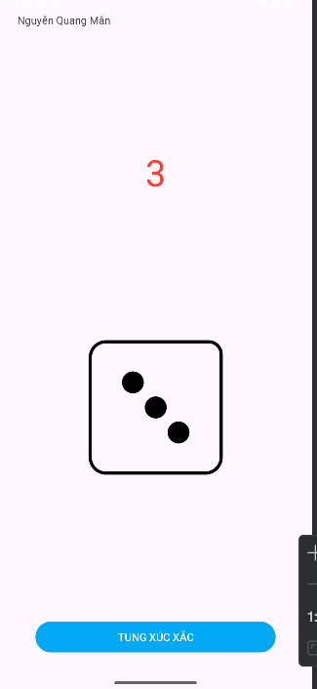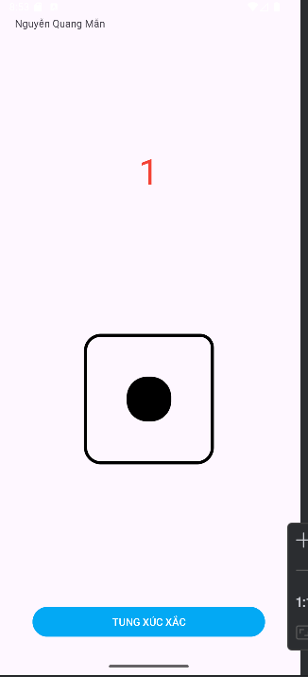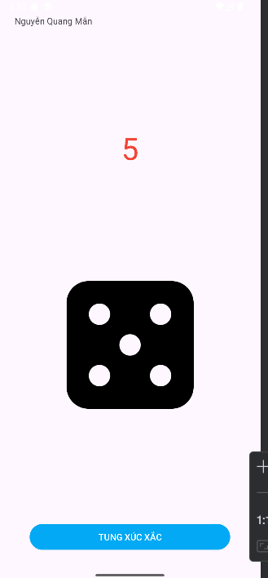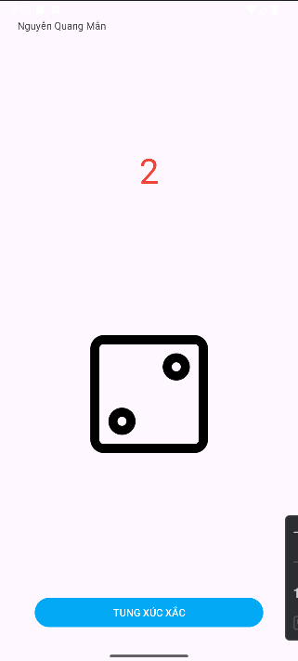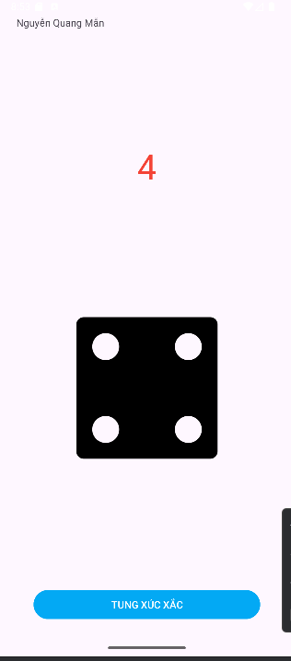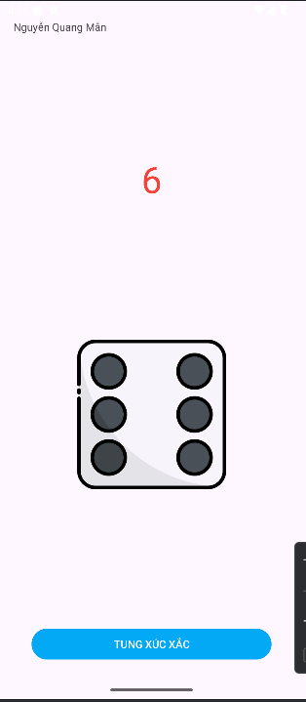
Bài 3
Goidien.java
package com.example.lab1;
import androidx.annotation.NonNull;
import androidx.appcompat.app.AppCompatActivity;
import androidx.core.app.ActivityCompat;
import androidx.core.content.ContextCompat;
import android.Manifest;
import android.content.Intent;
import android.content.pm.PackageManager;
import android.net.Uri;
import android.os.Bundle;
import android.view.View;
import android.widget.Button;
import android.widget.EditText;
import android.widget.Toast;
public class Goidien extends AppCompatActivity {
private EditText edtPhoneNumber, edtMessage;
private Button btnCall, btnSMS;
private static final int REQUEST_CALL = 1;
@Override
protected void onCreate(Bundle savedInstanceState) {
super.onCreate(savedInstanceState);
setContentView(R.layout.goidien); // Giao diện riêng cho bài tập 3
// Ánh xạ view
edtPhoneNumber = findViewById(R.id.edtPhoneNumber);
edtMessage = findViewById(R.id.edtMessage);
btnCall = findViewById(R.id.btnCall);
btnSMS = findViewById(R.id.btnSMS);
// Xử lý nút gọi điện
btnCall.setOnClickListener(new View.OnClickListener() {
@Override
public void onClick(View v) {
makePhoneCall();
}
});
// Xử lý nút gửi SMS
btnSMS.setOnClickListener(new View.OnClickListener() {
@Override
public void onClick(View v) {
sendSMS();
}
});
}
// Hàm gọi điện
private void makePhoneCall() {
String number = edtPhoneNumber.getText().toString().trim();
if (number.isEmpty()) {
Toast.makeText(this, "Vui lòng nhập số điện thoại", Toast.LENGTH_SHORT).show();
return;
}
if (ContextCompat.checkSelfPermission(this, Manifest.permission.CALL_PHONE)
!= PackageManager.PERMISSION_GRANTED) {
ActivityCompat.requestPermissions(this,
new String[]{Manifest.permission.CALL_PHONE}, REQUEST_CALL);
} else {
String dial = "tel:" + number;
startActivity(new Intent(Intent.ACTION_CALL, Uri.parse(dial)));
}
}
// Hàm gửi tin nhắn
private void sendSMS() {
String number = edtPhoneNumber.getText().toString().trim();
String message = edtMessage.getText().toString().trim();
if (number.isEmpty() || message.isEmpty()) {
Toast.makeText(this, "Vui lòng nhập số và nội dung tin nhắn", Toast.LENGTH_SHORT).show();
return;
}
Intent intent = new Intent(Intent.ACTION_SENDTO);
intent.setData(Uri.parse("smsto:" + number)); // chỉ gửi SMS
intent.putExtra("sms_body", message);
startActivity(intent);
}
// Xử lý quyền gọi điện
@Override
public void onRequestPermissionsResult(int requestCode, @NonNull String[] permissions,
@NonNull int[] grantResults) {
super.onRequestPermissionsResult(requestCode, permissions, grantResults);
if (requestCode == REQUEST_CALL) {
if (grantResults.length > 0 && grantResults[0] == PackageManager.PERMISSION_GRANTED) {
makePhoneCall();
} else {
Toast.makeText(this, "Quyền gọi điện bị từ chối", Toast.LENGTH_SHORT).show();
}
}
}
}
Goidien.xml
<?xml version="1.0" encoding="utf-8"?>
<LinearLayout xmlns:android="http://schemas.android.com/apk/res/android"
android:layout_width="match_parent"
android:layout_height="match_parent"
android:orientation="vertical"
android:padding="24dp"
android:gravity="center">
<TextView
android:layout_width="wrap_content"
android:layout_height="wrap_content"
android:text="Nguyễn Quang Mẫn"/>
<EditText
android:id="@+id/edtPhoneNumber"
android:layout_width="match_parent"
android:layout_height="wrap_content"
android:hint="Nhập số điện thoại"
android:inputType="phone"
android:textSize="18sp" />
<EditText
android:id="@+id/edtMessage"
android:layout_width="match_parent"
android:layout_height="wrap_content"
android:hint="Nhập nội dung tin nhắn"
android:inputType="textMultiLine"
android:lines="3"
android:gravity="top"
android:textSize="18sp"
android:layout_marginTop="12dp" />
<Button
android:id="@+id/btnCall"
android:layout_width="match_parent"
android:layout_height="wrap_content"
android:text="📞 GỌI ĐIỆN"
android:backgroundTint="#4CAF50"
android:textColor="@android:color/white"
android:layout_marginTop="20dp" />
<Button
android:id="@+id/btnSMS"
android:layout_width="match_parent"
android:layout_height="wrap_content"
android:text="💬 GỬI SMS"
android:backgroundTint="#03A9F4"
android:textColor="@android:color/white"
android:layout_marginTop="12dp" />
</LinearLayout>

Kết quả
